WAD ASSIGNMENT-8

<!DOCTYPE html>

<html>

<head>

<meta charset="UTF-8" />

<title>Book Example 12</title>

<script src="https://unpkg.com/react@16/umd/react.development.js"></script>

<script src="https://unpkg.com/react-dom@16/umd/react-dom.development.js"></script>

<script src="https://unpkg.com/babel-standalone@6/babel.min.js"></script>

<style>

#container {

padding: 50px;

background-color: #FFF;

}

</style>

</head>

<body>

<div id="container">

</div>

<script type="text/babel">

var destination = document.querySelector("#container");

class Colouriser extends React.Component {

constructor(props) {

super(props);

this.state = {

color: "",

oldClr: "",

bgColour: "white"

};

this.clrVal = this.clrVal.bind(this);

this.setNewClr = this.setNewClr.bind(this);

}

clrVal(e) {

this.setState({

color: e.target.value

});

}

setNewClr(e) {

e.preventDefault();

if (this.state.color !== "") {

this.setState({

bgColour: this.state.color,

oldClr: this.state.color,

color: ""

});

}

}

render() {

var colorisesrBox = {

backgroundColor: ",#fff",

border: "10px #3c3c3c solid",

display: "inline-block",

padding: "50px",

}

var colorBox = {

boxShadow: "0 0 20px #171717",

backgroundColor: this.state.bgColour,

width: "250px",

height: "250px",

marginBottom: "30px"

}

var btnStyle = {

marginLeft: "3px",

fontSize: "16px",

backgroundColor: "gray",

color: "#e4e4e4",

border: "none",

padding: "10px"

};

var inpStyle = {

backgroundColor: "#fff",

fontSize: "16px",

width: "180px",

padding: "10px"

}

console.log("render: Counter component");

return (

<div style={colorisesrBox}>

<div style={colorBox}></div>

<form onSubmit={this.setNewClr} id="Formid">

<input onChange={this.clrVal} style={inpStyle}

placeholder="Enter a color value"></input>

<button style={btnStyle} type="submit" preventDefault>go</button>

</form>

</div>

);

}

};

ReactDOM.render(

<div>

<Colouriser />

</div>,

destination

);

</script>

</body>

</html>

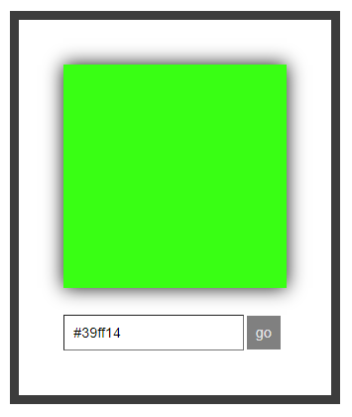

2)

<!DOCTYPE html>

<html>

<head>

<meta charset="UTF-8" />

<title>Clear Using Refs</title>

<script src="https://unpkg.com/react@16/umd/react.development.js"></script>

<script src="https://unpkg.com/react-dom@16/umd/react-dom.development.js"></script>

<script src="https://unpkg.com/babel-standalone@6/babel.min.js"></script>

<style>

#container {

padding: 50px;

}

</style>

</head>

<body>

<div id="container">

<form action=""></form>

</div>

<script type="text/babel">

var destination = document.querySelector("#container");

class ClearInput extends React.Component {

constructor(props) {

super(props);

this.state = {

valInput: ""

};

this.Value = this.Value.bind(this);

this.clrValue = this.clrValue.bind(this);

}

Value(e) {

this.setState({

valInput: e.target.value

});

}

clrValue(e) {

if (this.state.valInput !== "") {

this.setState({

valInput: ""

});

}

}

render() {

var outBoxStyle = {

backgroundColor: "#588ced",

border: "4px solid #3966b8",

display: "inline-block",

padding:"50px"

}

var btnStyle = {

marginLeft: "50px",

fontSize: "16px",

backgroundColor: "#fff",

color: "#323232",

border: "none",

padding: "10px"

};

var inpStyle = {

backgroundColor: "#fff",

border: "1px solid #161616",

fontSize: "16px",

width: "180px",

padding: "10px"

}

console.log("render: Counter component");

return (

<div style={outBoxStyle}>

<form onSubmit={this.clrValue} id="Formid">

<input onChange={this.Value} style={inpStyle}></input>

<button style={btnStyle} type="submit" preventDefault>Clear</button>

</form>

</div>

);

}

};

ReactDOM.render(

<div>

<ClearInput />

</div>,

destination

);

</script>

</body>

</html>

